Homework 1

Lei Zang

The development path of memory of PC

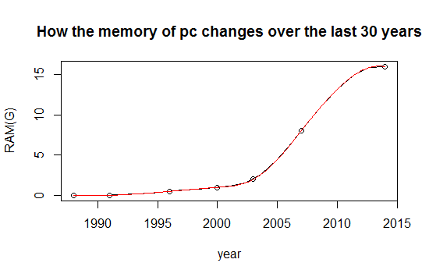

Logistic Regression

Logistic Regression is a regression model where the dependent variable (DV) is categorical. This article covers the case of a binary dependent variable—that is, where the output can take only two values, "0" and "1", which represent outcomes such as pass/fail, win/lose, alive/dead or healthy/sick. Cases where the dependent variable has
more than two outcome categories may be analysed in multinomial logistic regression, or,
if the multiple categories are ordered, in ordinal logistic regression.[2] In the terminology of economics, logistic regression is an example of a qualitative response/discrete choice model.

Homework 2

Lei Zang

Question 1

Code:

x = 6

n = 1000 lambda = 2
p = lambda / n

dbinom (x,2*n,p) # binomial probability mass function dpois (x, 2*lambda ) # Poisson probability mass function dpois (0, 5 )

Question 2

Code:

plot(year,number,type = "b",

col="black",main = "The history of computer memory",

sub = "This is the change in the number of types of computer memory",

xlab = "year",ylab = "The number of memory")

barplot(number,

xlab = "year",ylab ="The number of memory ")

Question 3

Code: lambda=2 x=seq(0:6)
P<-data.frame(dpois(x,lambda))

sum<-(P[1,]+P[7,]+P[2,]+P[6,]+P[3,]+P[5,]+P[4,]+P[4,])

sum lambda=5 x=0
dpois(x,lambda)

Homework 3

Lei Zang

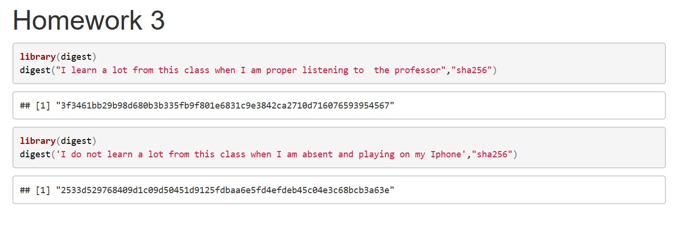

Digital Signature Algorithm

Lei Zang

What is a digital signature

A digital signature is a mathematical technique used to validate the authenticity and integrity
of a message, software or digital document.

Common digital signature algorithm

1. RSA-based signature schemes, such as RSA-PSS.

2. DSA and its elliptic curve variant ECDSA.

3. Edwards-curve Digital Signature Algorithm and its Ed25519 variant.

4. ElGamal signature scheme as the predecessor to DSA, and variants Schnorr signature
and Pointcheval–Stern signature algorithm.

How does digital signature algorithm work

Digital signatures are based on public key encryption, also known as asymmetric encryption. Using a public key algorithm such as RSA, you can generate two keys that are mathematically linked: a private and a public key. To create a digital signature, the signature software (such as an e-mail program) creates a one-way hash of the electronic data to be signed. Then the private key is used to encrypt the hash. The encrypted hash and other information such as the hash algorithm are digital signatures. The reason for encrypting a hash rather than an entire message or document is that the hash function can convert any input to a fixed-length value, which is usually much shorter. This saves time because the hash is much faster than the signature.

Save and read Jason format data
in R

Lei Zang

This is how to save and read Jason format data in R

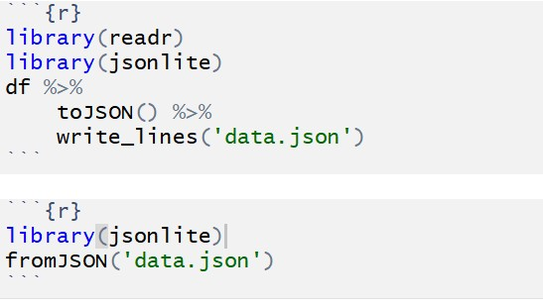

Question 4

Lei Zang

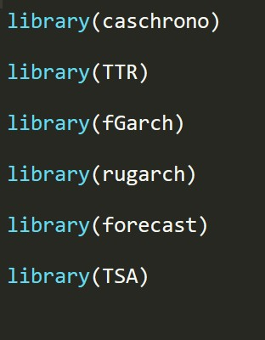

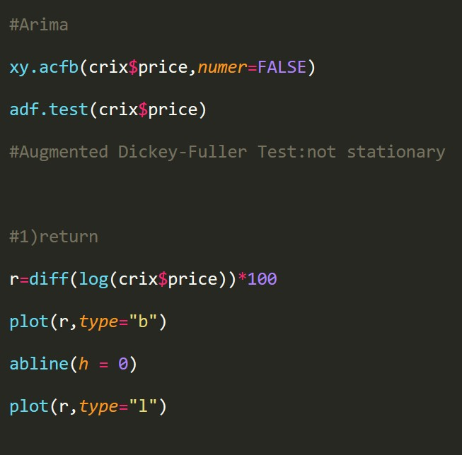

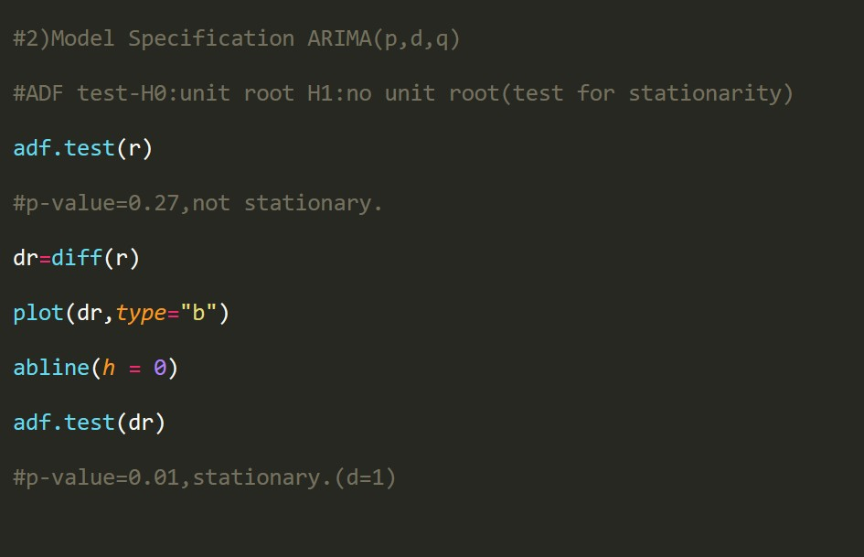

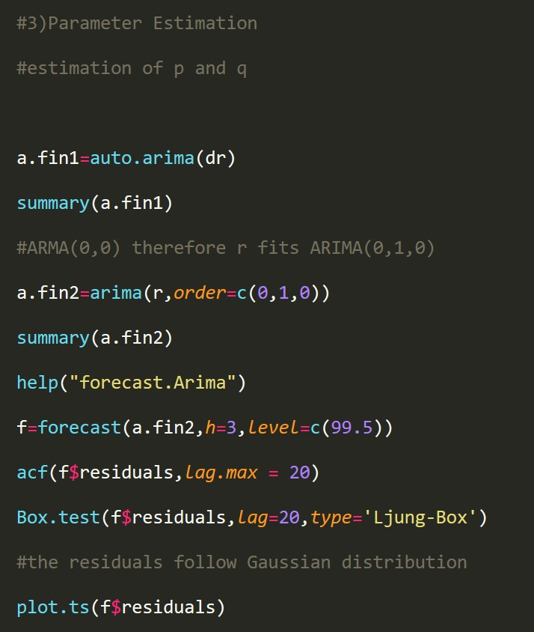
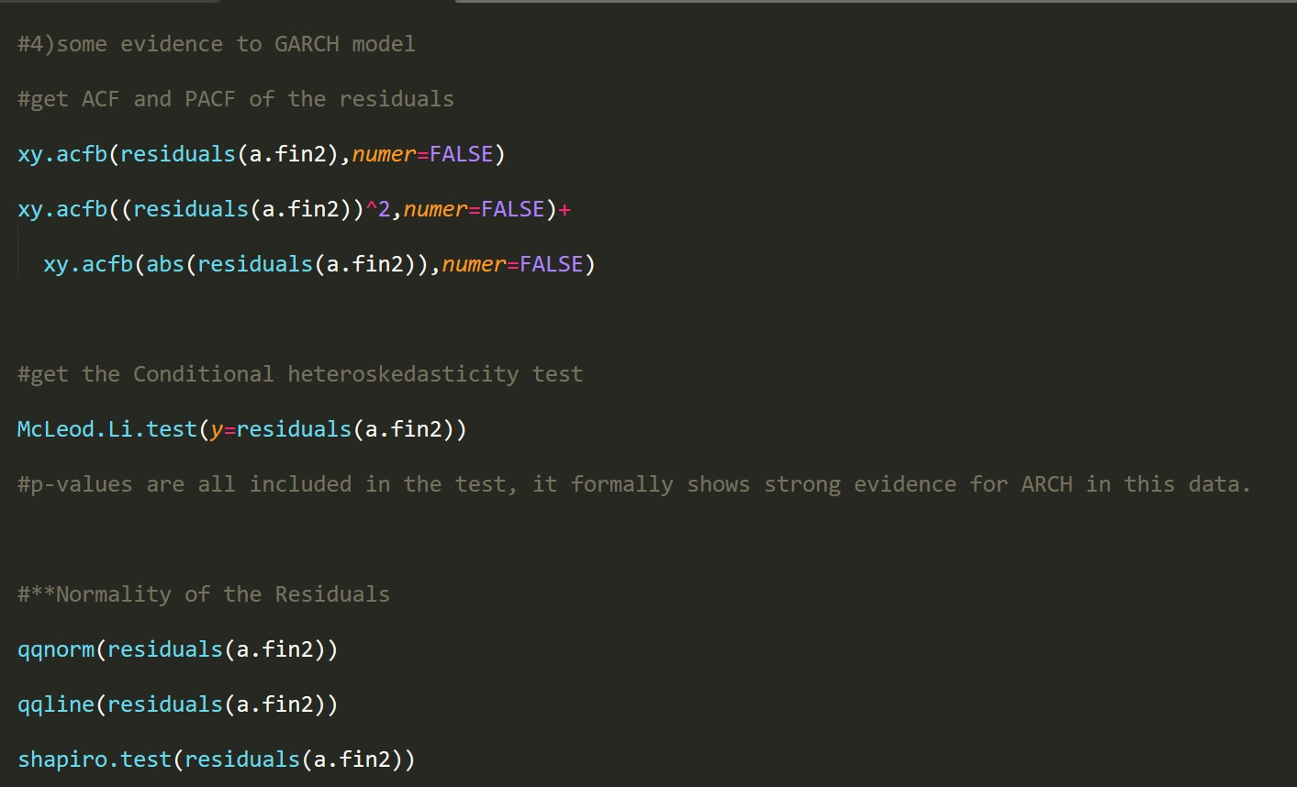

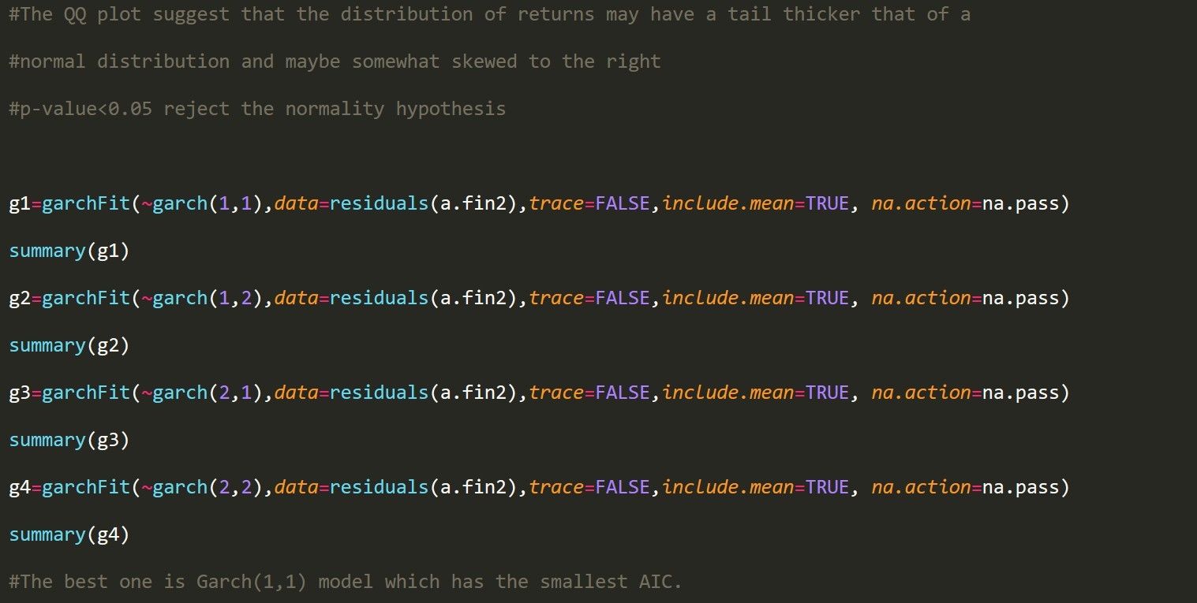

Homework 4

Lei Zang

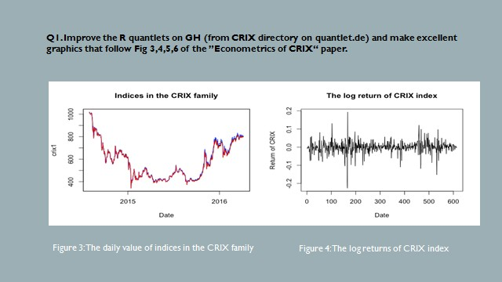

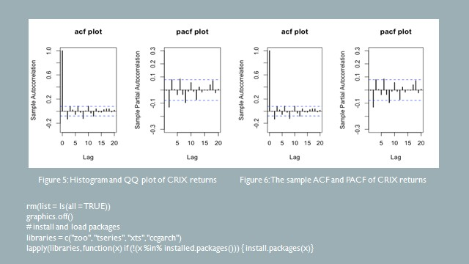

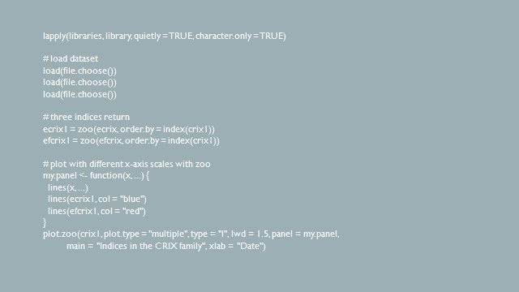

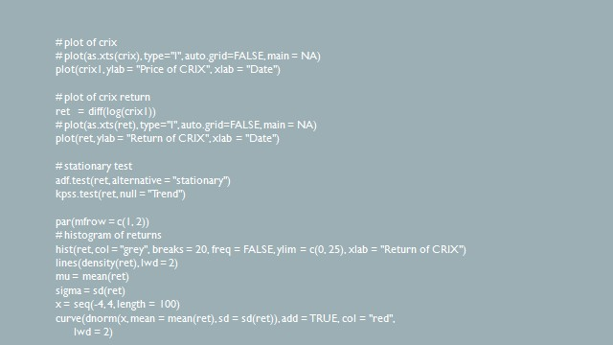

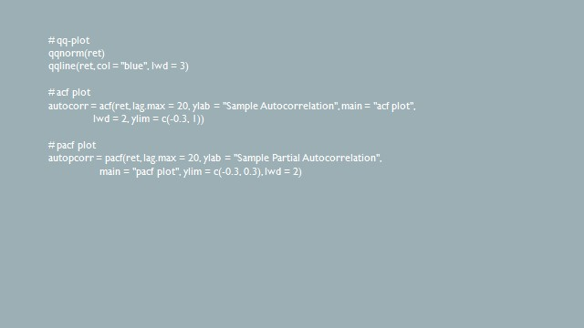

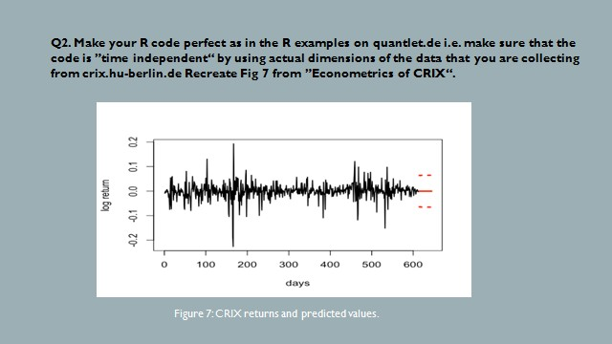

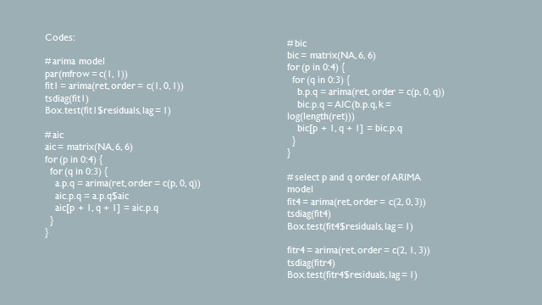

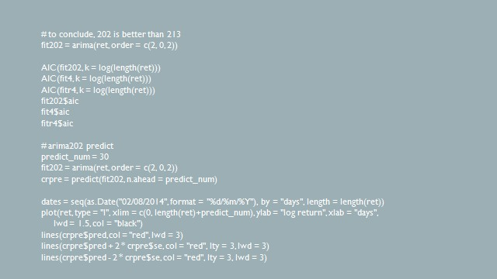

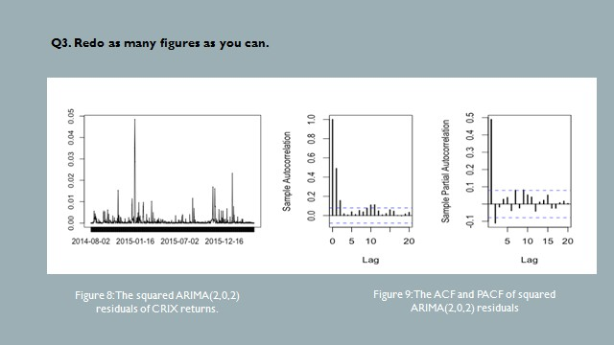

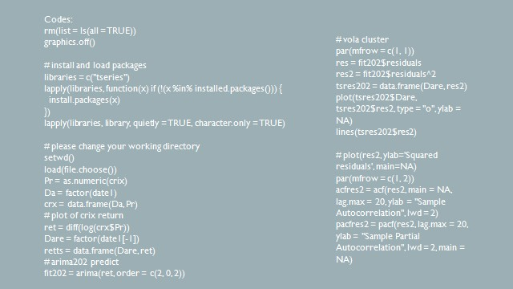

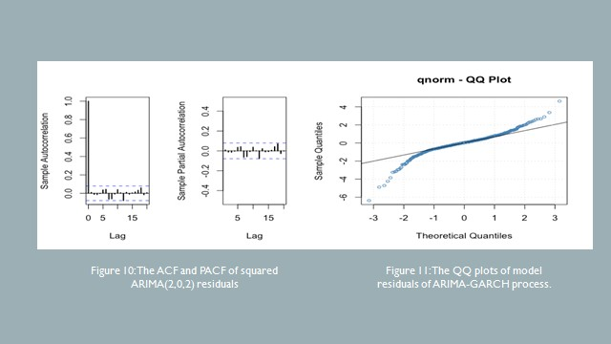

Homework 5

Lei Zang

Q1. do a word cloud for Shakesspeare’s dramas.
Romeo and Julia, Julius Caesar, Hamlet.

rm(list = ls())
#install.packages("RCurl")
#install.packages("XML") library(RCurl) library(XML)
url1 = "http://shakespeare.mit.edu/romeo_juliet/full.html" url2 = "http://shakespeare.mit.edu/julius_caesar/full.html" url3 = "http://shakespeare.mit.edu/hamlet/full.html"
html1 = readLines(url1, encoding = "UTF-8") html2 = readLines(url2, encoding = "UTF-8") html3 = readLines(url3, encoding = "UTF-8") html1 = htmlParse(html1, encoding = "UTF-8") html2 = htmlParse(html2, encoding = "UTF-8") html3 = htmlParse(html3, encoding = "UTF-8")
#install.packages("bitops")
#install.packages("stringr") library(bitops) library(stringr)
abs1 = lapply(url1, FUN = function(x) htmlParse(x, encoding = "Latin-1")) abs2 = lapply(url2, FUN = function(x) htmlParse(x, encoding = "Latin-1")) abs3 = lapply(url3, FUN = function(x) htmlParse(x, encoding = "Latin-1")) clean_txt = function(x) {
cleantxt = xpathApply(x, "//body//text()
[not(ancestor :: script)][ not(ancestor :: style)]
[not(ancestor :: noscript)] " ,xmlValue)
cleantxt = paste(cleantxt, collapse="\n") cleantxt = str_replace_all(cleantxt, "\n", " ") cleantxt = str_replace_all(cleantxt, "\r", "") cleantxt = str_replace_all(cleantxt, "\t", "") cleantxt = str_replace_all(cleantxt, "<br>", "")
return(cleantxt)
}

cleantxt1 = lapply(abs1,clean_txt) cleantxt2 = lapply(abs2,clean_txt) cleantxt3 = lapply(abs3,clean_txt) vec_abs1 = unlist(cleantxt1) vec_abs2 = unlist(cleantxt2) vec_abs3 = unlist(cleantxt3)

#install.packages("tm")
#install.packages("SnowballC")
library(tm)
library(SnowballC)
abs1 = Corpus(VectorSource(vec_abs1)) abs2 = Corpus(VectorSource(vec_abs2)) abs3 = Corpus(VectorSource(vec_abs3))
abs_dtm1 = DocumentTermMatrix(abs1, control = list(
stemming = TRUE, stopwords = TRUE, minWordLength = 3,
removeNumbers = TRUE, removePunctuation = TRUE)) abs_dtm2 = DocumentTermMatrix(abs2, control = list( stemming = TRUE, stopwords = TRUE, minWordLength = 3, removeNumbers = TRUE, removePunctuation = TRUE)) abs_dtm3 = DocumentTermMatrix(abs3, control = list( stemming = TRUE, stopwords = TRUE, minWordLength = 3, removeNumbers = TRUE, removePunctuation = TRUE))
##WordCloud instal.packages("ggplot2") install.packages("wordcloud") library(ggplot2) library(wordcloud)
freq1 = colSums(as.matrix(abs_dtm1))
freq2 = colSums(as.matrix(abs_dtm2))
freq3 = colSums(as.matrix(abs_dtm3))
wf1 = data.frame(word=names(freq1), freq=freq1) wf2 = data.frame(word=names(freq2), freq=freq2) wf3 = data.frame(word=names(freq3), freq=freq3)

#Romeo and Juliet
plot1 = ggplot(subset(wf1, freq>15), aes(word, freq1))
plot1 = plot1 + geom_bar(stat="identity")
plot1 = plot1 + theme(axis.text.x=element_text(angle=45,
hjust=1))
plot1
freq1 = colSums(as.matrix(abs_dtm1))
dark2_1 = brewer.pal(6, "Dark2")
wordcloud(names(freq1), freq1, max.words=100, rot.per=0.2,
colors=dark2_1)
#Julius Caeser
plot2 = ggplot(subset(wf2, freq>15), aes(word, freq2))
plot2 = plot2 + geom_bar(stat="identity")
plot2 = plot2 + theme(axis.text.x=element_text(angle=45, hjust=1))
plot2
freq2 = colSums(as.matrix(abs_dtm2))
dark2_2 = brewer.pal(6, "Dark2")
wordcloud(names(freq2), freq2, max.words=100, rot.per=0.2, colors=dark2_2)
#Hamlet
plot3 = ggplot(subset(wf3, freq>15), aes(word, freq3))
plot3 = plot3 + geom_bar(stat="identity")
plot3 = plot3 + theme(axis.text.x=element_text(angle=45, hjust=1))
plot3
freq3 = colSums(as.matrix(abs_dtm3))
dark2_3 = brewer.pal(6, "Dark2")
wordcloud(names(freq3), freq3, max.words=100, rot.per=0.2, colors=dark2_3)

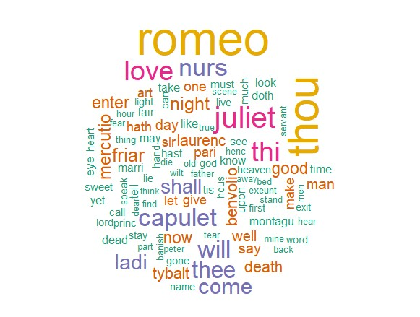

Figure 1: Romeo and
Julia

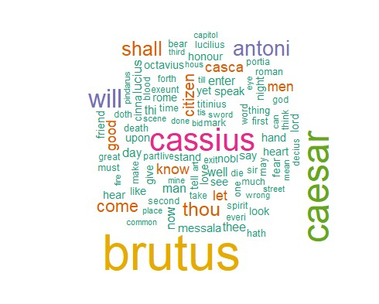

Figure 2: Julius Caesar

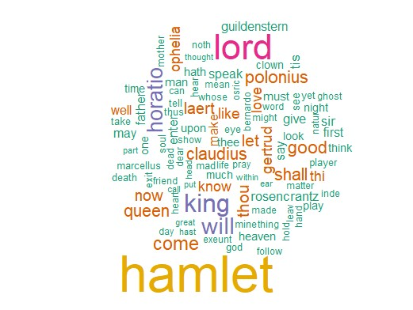

Figure 3: Hamlet

Q2. calculate the histogram of words

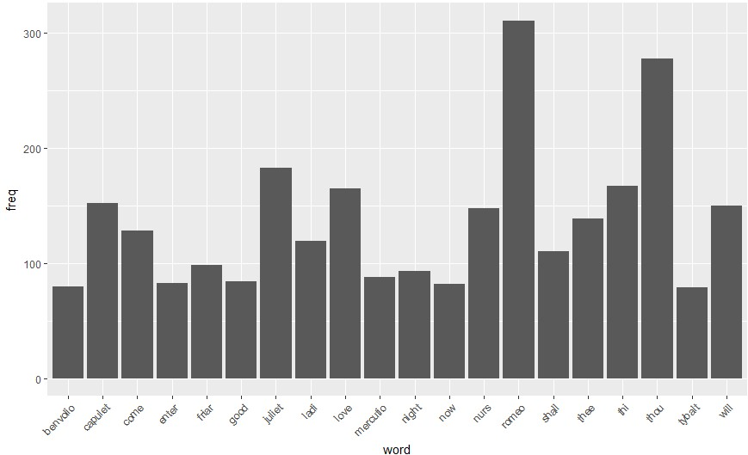

Figure 4: Romeo and
Julia

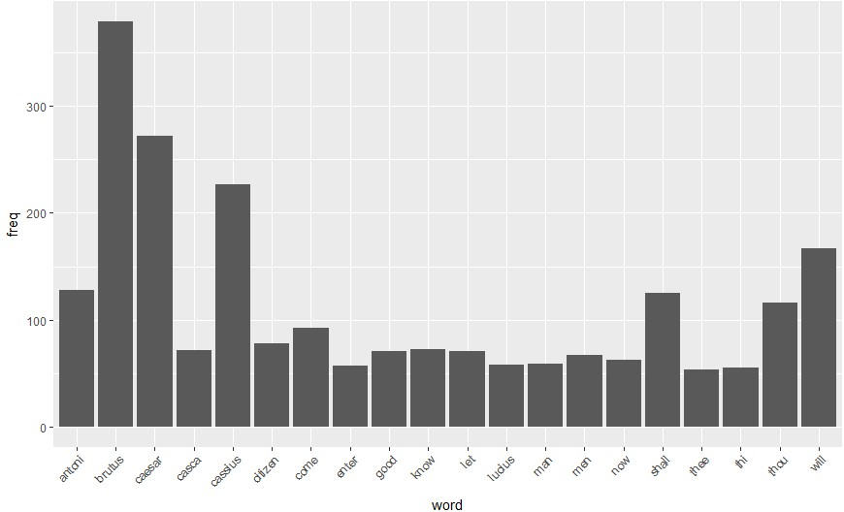

Figure 5: Julius Caesar

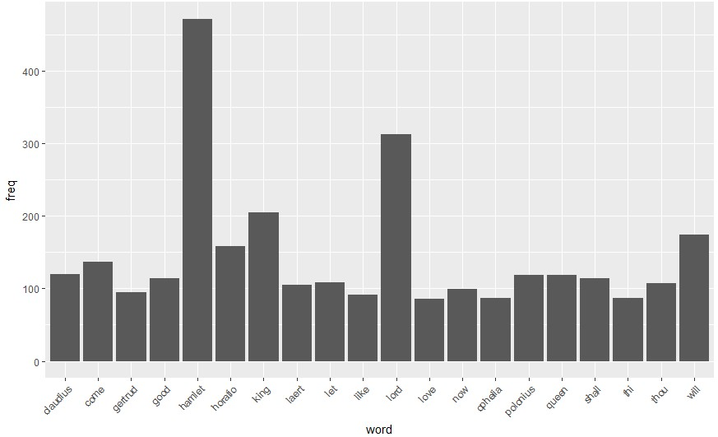

Figure 6: Hamlet

